**AGRO-X**

**Description of the components used and Schematics**

* **COMPONENTS USED:**

1. GY-906 MLX90614ESF -BCC Contactless Temperature Sensor:
   1. Input: 3.3V
   2. Sensing range: 4 CM -10 cm
   3. Field of view: 35 degrees
   4. Sensor temperature: -40 to +85°C
   5. 10k Pull-up resistors for the I2C interface

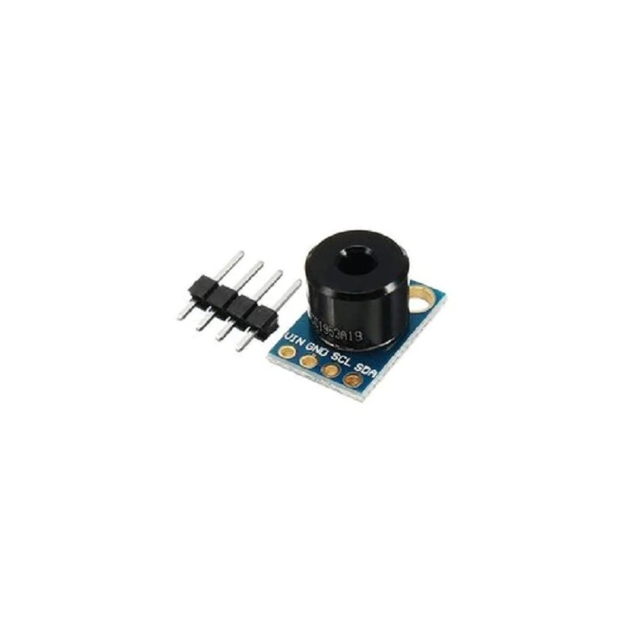

1. It is an infrared thermometer for use with Arduino or any microcontroller that can communicate with it through its I2C interface.
2. An internal 17-bit ADC and a powerful DSP contribute to the MLX90614’s high accuracy and resolution.
3. The sensor has a field of view of **35 degrees** and returns the average temperature value of all objects within this field of view.

**Purpose:** **In this project, it is utilized to continually read the object's temperature and the ambient temperature. The system will kick in**

**when the temperature difference exceeds a specific pre-set threshold.**

# HC-12 433 SI4463 Wireless Serial Module:

* 1. Operating Frequency Range:  433.4—473.0MHz
  2. Transmit Power Max: 20dBm
  3. Power Supply Voltage: DC 3.2V ~5.5V
  4. Long Communication Distance:1000 meters at the default setting
  5. Maximum transmit power:100mW (20dBm)
  6. Reciever Sensitivity-116dBm
  7. Baud rate:5000bps

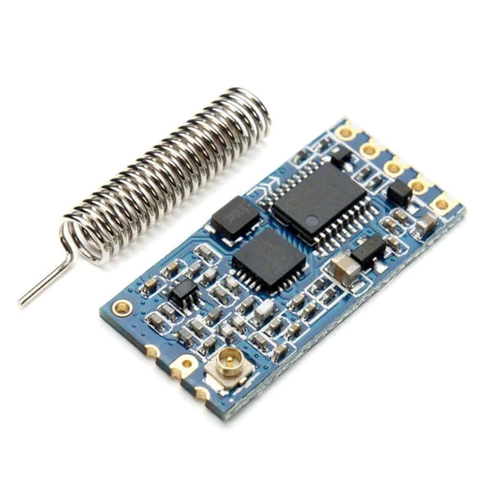

* + 1. Multi-channel embedded wireless data transmission module
    2. The four UART modes of FU1, FU2, FU3, FU4, the average operating current is 3.6mA, 80μA, 16mA and 16mA, the maximum operating current is 100mA
    3. Based on the SI4463 EZRadioPro family chip by SiLabs.
    4. has an onboard STM8S003F3P6 MCU which is communicating with the SI4463 so that the user can communicate with the HC12 module using a simple TTL 2 wire serial interface (RX, TX, GND)

**Purpose**: **Here, it's utilized to turn the system on and off seamlessly, communicate wirelessly between the transmitter and the receiver,**

**and remotely alert the owner of any intrusions.**

1. Arduino nano:
   1. Input 5V ~ 12V DC
   2. **8** Analog input ports: A0 ~ A7
   3. 14 Digital input/output ports: TX, RX, D2 ~ D13
   4. 1 pair of TTL level serial transceiver ports RX / TX
   5. Using Atmel Atmega328P-AU MCU

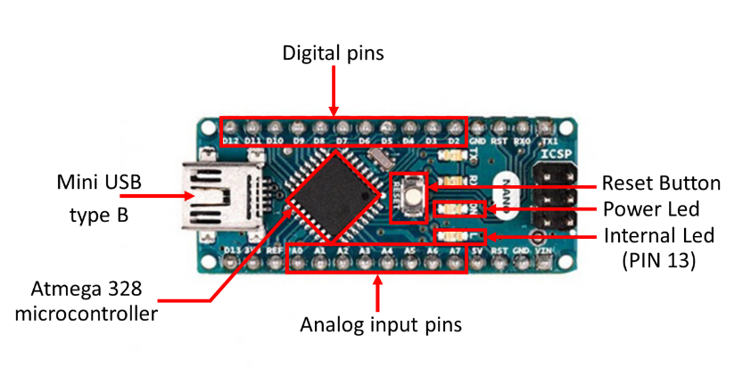

* + 1. Widely known micro-controller boards to create a multitude of different projects on robotics, home automation, industrial automation, etc.
    2. Can be programmed to control the way buttons, motors, switches, lights, and other electronic components work together.
    3. Creates an accessible way for software developers to enter the world of microcontroller programming.
    4. Micro-controller interface built around an ATMEL-ATMEGA processor coupled with an integrated development environment (IDE) for creating logic on the chip.

**Purpose: It serves as the system's brain, computing and coordinating every,**

**taking required action upon receiving sensor inputs, and exercising control**

**over all the electronics.**

# 5V Dual Channel Relay Module:

* 1. Low-Level Trigger Relay Module
  2. Triggering input voltage 3.3V – 5V
  3. Back EMF protection
  4. Opto isolation circuitry
  5. Diode current protection, short response time
  6. AC Control Voltage: 250V @max.10A
  7. DC Control Voltage: 30V @max. 10A
  8. Relay Module with Optocoupler Arduino for PIC ARM

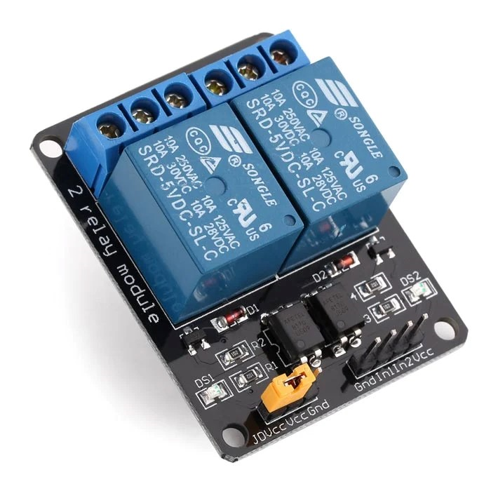

**Purpose:** **Utilized to flicker the high beam floodlights and electrically switch on and off the entire system**

# Digital LDR Module:

* 1. LM393-based design.
  2. Detects ambient brightness and light intensity.
  3. Adjustable sensitivity
  4. Output Digital – 0V to 5V,
  5. Operating Voltage: 3.3V to 5V DC.
  6. Operating Current: 15ma.

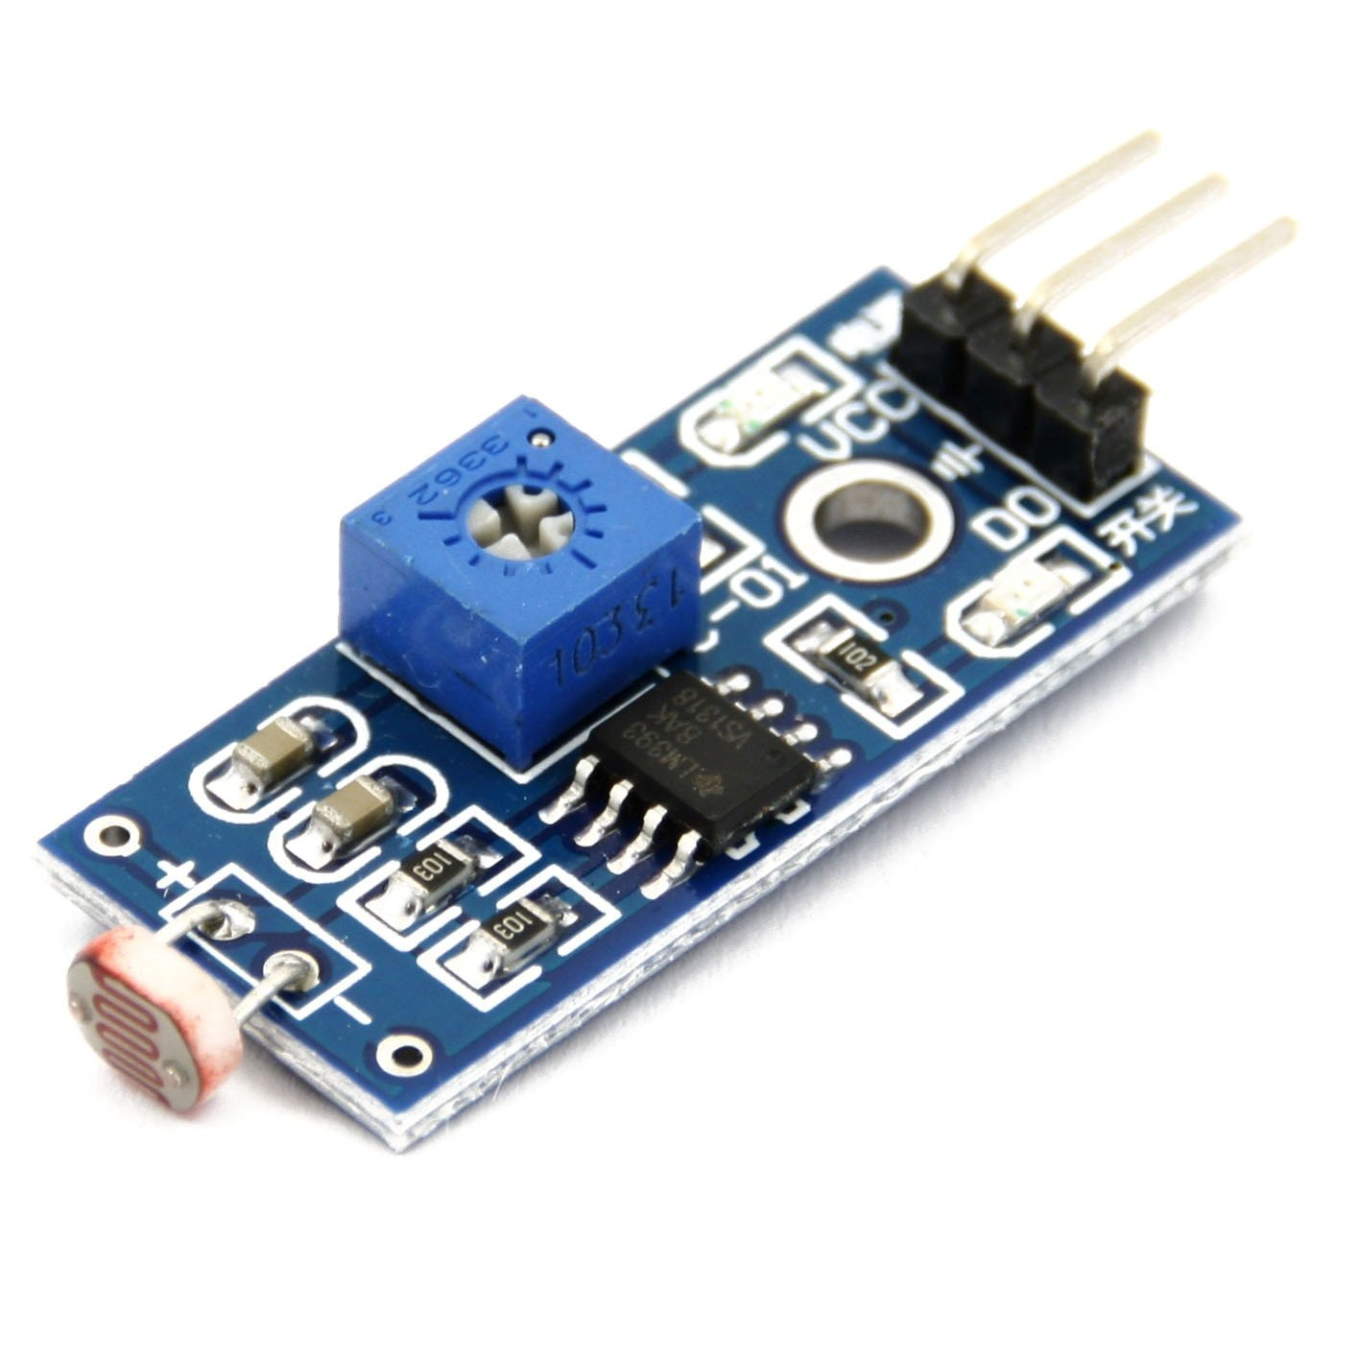

* + 1. LDR Module a Photosensitive resistor module most sensitive to environmental light intensity is generally used to detect the ambient brightness and light intensity.
    2. The output of the module goes high in the presence of light and it becomes low in the absence of light.
    3. The sensitivity of signal detection can be adjusted using the potentiometer
    4. Threshold (sensitivity) tuneable

**Purpose:** **Utilized to receive the laser diode's reflected light, and when the incoming light's intensity falls below the threshold value previously determined, it produces a high signal.**

# LM2596 Buck Converter:

* 1. HV DC-DC
  2. Adjustable step-down module
  3. Input voltage: 4.5-40V
  4. Output voltage: (3-35V) continuously adjustable
  5. Minimum pressure: 1.5V
  6. Output current: rated current 2A, 3A maximum
  7. Output Power: 15W maximum

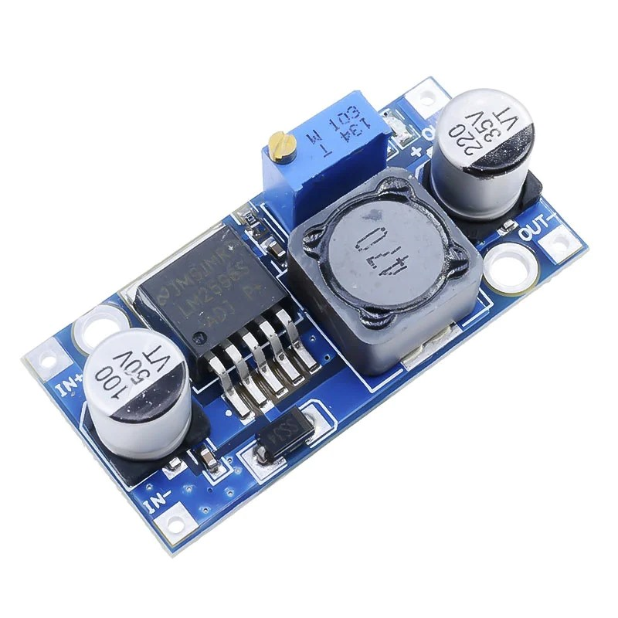

**Purpose:** **Since the system as a whole operates on two distinct voltage levels, different electronic parts must operate with the proper voltage stated.**

# Laser Dot Diode:

* 1. 6mm
  2. Output Power: 5mW
  3. Working Voltage: 5V DC
  4. Working temperature: -10 ℃~＋40 ℃
  5. Housing material: Copper
  6. Working life: >2000 hours
  7. Spot mode: Dot Facula
  8. Laser wavelength: 650nm red
  9. Operating current: <40mA

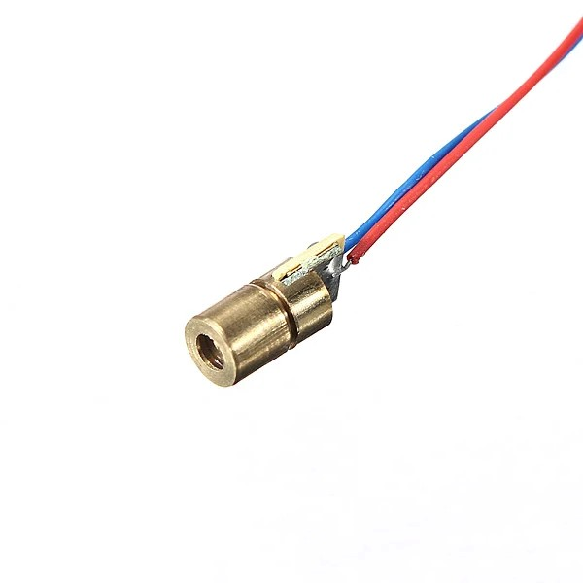

**Purpose:** **Emits a single laser beam that is reflected over the prone area limits and falls on the LDR sensor at the very end.**

1. 28BYJ-48 Stepper Motor and ULN2003 Stepper Motor Driver:
   1. Rated voltage: 5V DC
   2. Reduction Ratio: 64:1
   3. Step Angle: 5.625° /64
   4. Frequency: 100Hz
   5. Self-positioning Torque: >34. 3mN.m
   6. Friction torque: 600-1200 gf.cm
   7. Pull-in torque: 300 gf. Cm
   8. RPM: 15
   9. Unipolar

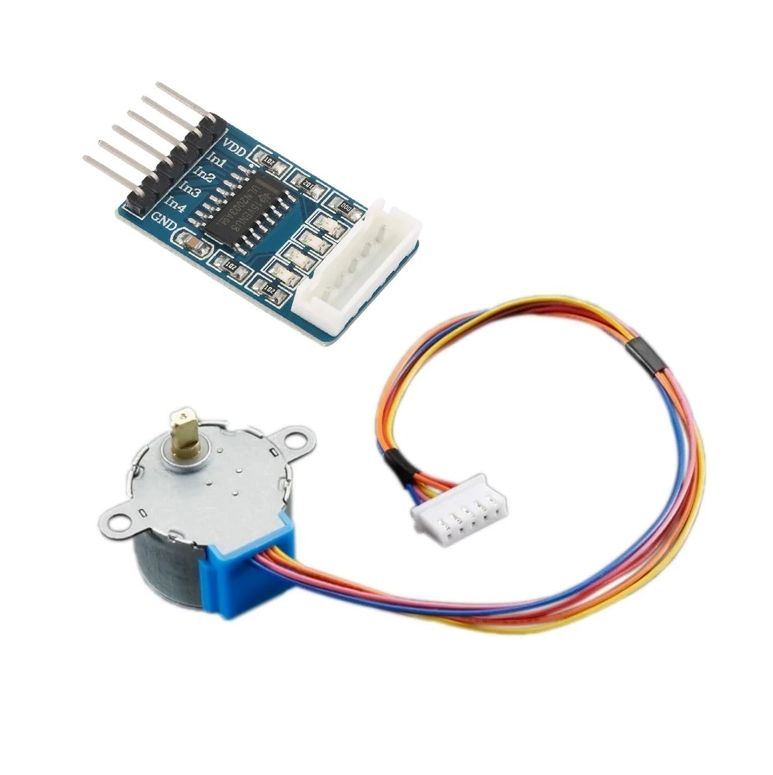

**Purpose:** **Due to the thermal sensor's limited detection angle of just 35 degrees, it is mounted on the motor shaft, and its rotation is determined based on the inputs given by the Arduino.**

* **PRINCIPLE:**
* Wild animals can cause significant damage to property and human lives when they invade rural areas, as is well known.
* Therefore, it is crucial to protect these areas and the people who live there from these invasions while also preventing harm to the animals.
* Our research has shown that animals are primarily scared of two things:

1) high beam flickering floodlights

2) specific acoustic frequencies.

* When the animals come in contact with high-beam flickering floodlights they get frightened and assume it as a sign of danger and discontinue their path.
* Coming to the frequency, every animal will have a certain audio frequency that they don’t want to hear or get irritated
  + For example: Elephants being such huge animals, they get irritated by the buzzing noise created by the honey bees which come between 50-550hz.
* Surprisingly many animals also hate this range.
* Hence our aim is to detect the incoming animals, generate a frequency that affects that particular animal followed by the flickering lights, deter them, and wirelessly alert the owner about the intrusion
* **WORKING:**
* This system uses two mechanisms, which function as two-step authentication, to validate the intrusion.
* One end of a laser beam is positioned 0.5 meters above the ground, and the beam is amplified after being reflected over the plantation and field boundaries.
* The LDR sensor is positioned at the other end, and the reflected laser beam is directed towards it.
* As long as a beam of light touches the LDR sensor, it sends a low signal; nevertheless, the system is activated as soon as the ray is obstructed anywhere along the projected path.
* With the aid of the stepper motor, the IR thermal sensor will now begin to sense the field's temperature.
* Constantly, the values are fetched to the microcontroller.
* If the sensor comes into contact with a hot body, the difference between the object's temperature and the ambient temperature rises quickly, surpassing the pre-set threshold value (which can be changed).
* At this point, both the laser and thermal conditions come true.
* Thus, the microcontroller evaluates that it is an intrusion and generates the frequency in accordance with the temperature that it detected. With frequency generation, the floodlights will also begin to flicker.
* The microcontroller wirelessly notifies the owner about the animal as soon as it detects an intrusion.
* This process will continue for X seconds, after which the thermal sensor will be fired once again until it detects no movement for Y rotations.
* Ultimately, a switch can remotely turn the entire system on and off at the owner's end.
* **SCHEMATICS:**

1. Reciever:

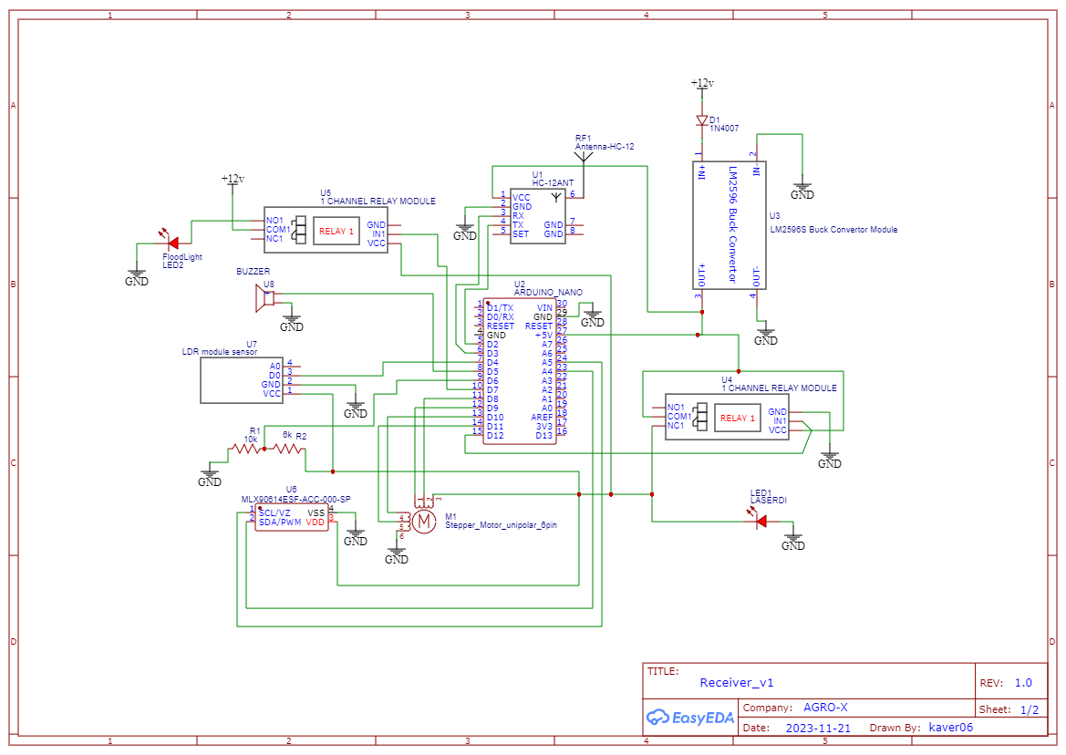

1. Transmitter:

